Ideation Phase
Define the Problem Statements

Date | 01-07-2026
Team ID
Project Name | ONLINE COMPLAINT REGISTRATION
Maximum Marks | 2 Marks

Customer Problem Statement Template:
Create a problem statement to understand your customer's point of view. The Customer Problem Statement template helps you focus on what matters to create experiences people will love.
A well-articulated customer problem statement allows you and your team to find the ideal solution for the challenges your customers face. Throughout the process, you’ll also be able to empathize with your customers, which helps you better understand how they perceive your product or service.

Reference: https://miro.com/templates/customer-problem-statement/
ONLINE COMPLAINT REGISTRATION:
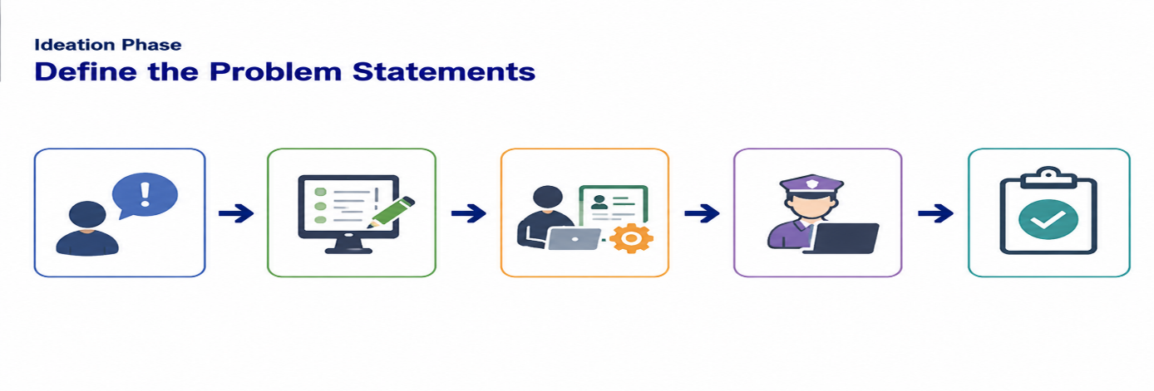

Problem Statement (PS) | I am (Customer) | I’m trying to | But | Because | Which makes me feel
Ordinary User | A citizen/user who wants to register and track complaints online. | Submit complaints easily, track their status, communicate with the assigned officer, and receive timely updates until the complaint is resolved. | The traditional complaint process is manual, time-consuming, lacks transparency, and users do not know the current status of their complaints. | Complaints are maintained manually with limited communication between users and authorities, resulting in delays and poor complaint management. | Frustrated, dissatisfied, and uncertain about whether my complaint will be resolved.
Administrator / Complaint Officer | An administrator responsible for managing complaints and assigning them to officers. | Manage complaints efficiently, assign them to suitable agents, monitor complaint progress, review feedback, and ensure timely resolution. | Managing complaints manually is difficult because complaints are scattered, assignment is inefficient, and monitoring complaint progress becomes challenging. | There is no centralized system to organize complaints, assign officers, update complaint status, or generate reports for monitoring. | Overloaded, inefficient, and unable to provide timely and transparent complaint resolution services.

